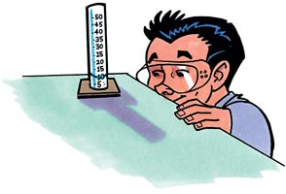  1. What is this picture teaching you about making measurements? | 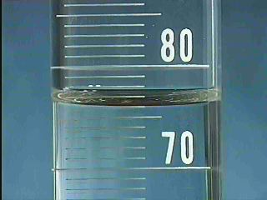  2. What is the volume of water in the graduated cylinder? | 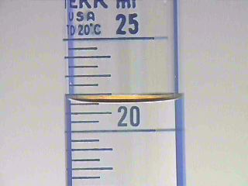  3. What is the volume of water in the graduated cylinder?
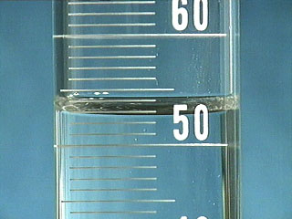  4. What is the volume of water in the graduated cylinder? | 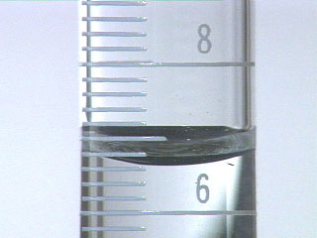  5. What is the volume of water in the graduated cylinder? | 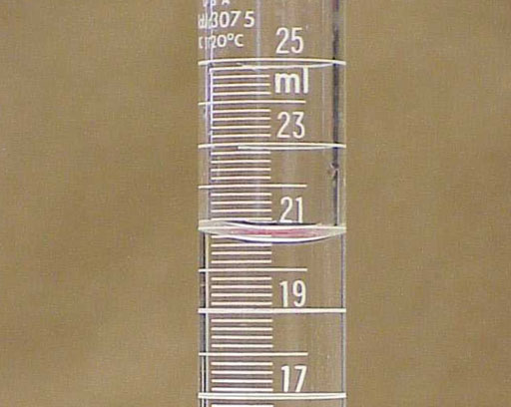  6. What is the volume of water in the graduated cylinder?
7. Draw a picture of the graduate cylinder. What is the volume of water in the graduated cylinder? | 8. Draw a picture of the graduate cylinder. What is the volume of water in the graduated cylinder? | 9. Draw a picture of the graduate cylinder. What is the volume of water in the graduated cylinder?
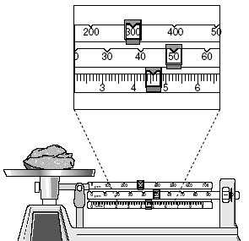  10. What is the mass of the object? | 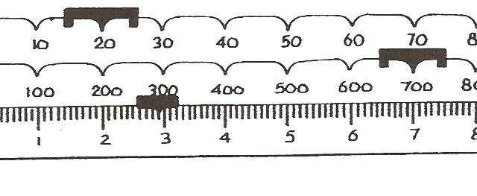  11. What is the mass of the object? | 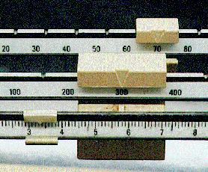  12 What is the mass of the object?
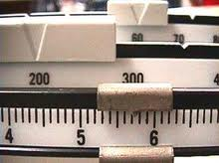  13. What is the mass of the object? | 14. Draw a picture of the three weights of the TBB. What is the mass of the object? | 15. Draw a picture of the three weights of the TBB. What is the mass of the object?

Calculating Density:

1. If an object has the same mass as number ______ and a volume of number _________ , what is its density? (Show your work)

2. If an object has the same mass as number ______ and a volume of number _________ , what is its density? (Show your work)

3. If an object has the same mass as number ______ and a volume of number _________ , what is its density? (Show your work)

4. If an object has the same mass as number ______ and a volume of number _________ , what is its density? (Show your work)

Instructions: Measure the Length and width of each bug or vegetable.

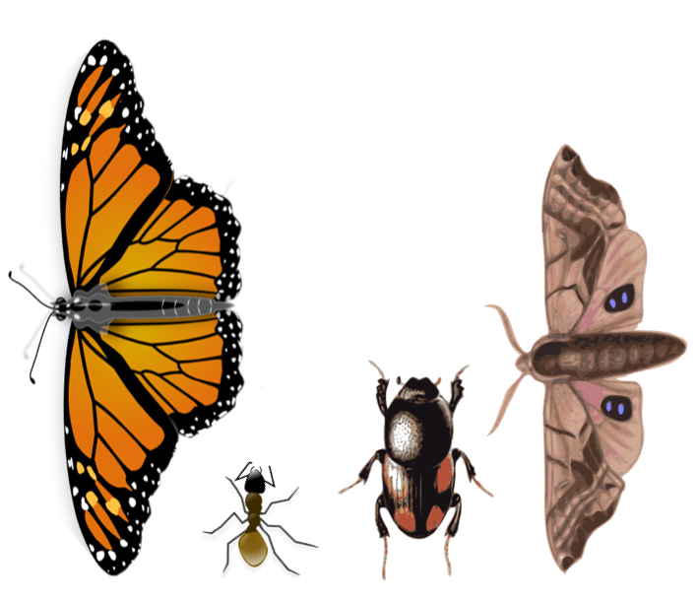

Length: _______ Length: _________ Length: ________ Length: ________

Width: _______ Width: _________ Width: _________ Width: _________

1. If the height of the butterfly is 2.4 cm, what volume would the smallest box be that could hold the butterfly? (Show all your work.)

2. Pretend that you want to create a display box like the one Ms. Yost has for her beetle. If the height of the beetle above is 3.3 cm, what is the volume of the smallest display box that could be built for it? (Show your work)

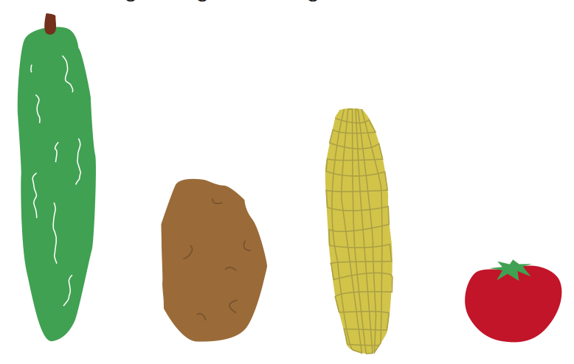

Length: _______ Length: _________ Length: ________ Length: ________

Width: _______ Width: _________ Width: _________ Width: _________

1. If the largest height of the vegetables above is 5.9 cm, what is the volume of the smallest box that could hold ALL of the vegetables above? Draw a picture of the arrangement of vegetables in the box. (Show all your work)

