Parts of the Cell (NOTES)
Eukaryotic (Eu=true) Cell Organelles and Functions
Organelle: a specialized structure within a cell. We will learn about TEN organelles.
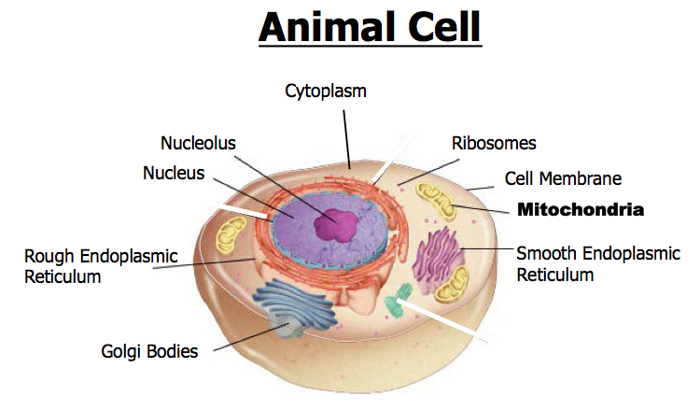

- Nucleus
Nickname: “The Control Center”
Function: ____________________________________________________________________________________
Parts:
- Nucleolus: dark spot in the middle of the nucleus that helps make ribosomes
Found in both _______________________ and ___________________________ cells

- Ribosomes
Function: _________________________________________________________
Found in ___________________ cells, prokaryotic and eukaryotic
Located: Cytoplasm

- Endoplasmic Reticulum (ER)
Nickname: “Roads”
Function: The internal __________________________ ____________________________ of the cell
Located: Cytoplasm
Found in both plant and animal cells

- Golgi Body
Nickname: The ____________________________________
Function: _____________________________, ___________________________ , and transports materials to different location inside/outside of the cell
Appearance: stack of pancakes
Located: Cytoplasm
Found in both plant and _____________________________ cells

- Lysosomes: circular, but bigger than ribosomes)
Nickname: “Clean-up Crews”
Function: to ________________________ ______________________ food into particles the rest of the cell can use and to _________________________ old cells
Located: Cytoplasm
Found in both _______________________ and animal cells

- Mitochondria
Nickname: “The Powerhouse”
Function: ____________________________________________________________________
- Breaks down food to make ATP
- ATP: is the major _______________________ for all cell activities that require energy
Located: Cytoplasm
Found in ______________________ plant and animal cells
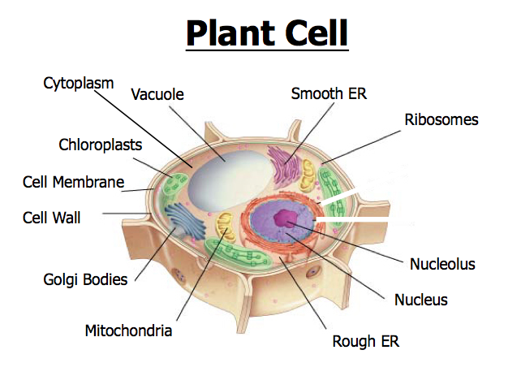

- Vacuoles
Function:
- Plant Cells
  - Very _________________________
  - Stores ________________________
  - This is what makes ________________________________ crisp
  - When there is no water, the plant wilts
- Animal Cells
  - ____________________________ than in plant cells
  - Stores/releases ______________________ products
  - Used in cellular ____________________________________
Located: Cytoplasm

- Chloroplasts
Function: traps _____________________ from the _________ to produce food for the plant cell
Located: Cytoplasm
- ________________________ in color because of chlorophyll, which is a green pigment
Found in _________________________ cells ONLY.

- Cell Wall
Function: provides _____________________ and ________________________ to the cell membrane
Located: Found _________________________ the cell membrane in ________________ cells ONLY

10. Cell Membrane
Functions:
- Separates the inside of the cell from its environment
- __________________________________________________________________________________________
  - Oxygen, carbon dioxide, wastes, food, etc…
Located:
- In plant cells, it is to the ___________________________________ of the cell wall
- In animal cells, it is the __________________________________________ part of the cell

