Paper Airplane Contest

Objective: I can create a paper airplane that flies at least 20 feet. I can create an airplane that can accurately hit a target.

Introduction: Go to tinyurl.com/EMSairplanes and answer the following questions.
- What makes paper airplanes fly? _________________________________
- Describe the difference you can feel when you wave your hand through the air when your palm is perpendicular to the ground and when it is parallel to the ground.

- What is wind resistance on a plane called? _______________________
- Besides drag, what other force is pulling on your plane? _____________________
- What is thrust? _____________________________________________________________________________________
- What is lift? _________________________________________________________________________________________
- A long flight occurs when these four forces—drag, gravity, thrust and lift—are ____________.
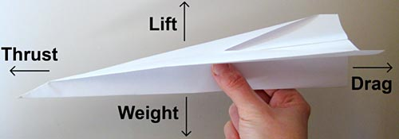
Questions: Which airplane design will be able to fly the furthest? Which airplane design will be the most accurate?

Research and Design: draw below what your airplane(s) will look like.

- Why did you choose the design that you chose?

- What is the name of the website (so you can go back tomorrow, if needed)?

Data Tables:
Distance (in meters) the plane went.

Trial 1 distance | Trial 2 distance | Trial 3 distance

Distance (in meters) from target

Trial 1 distance | Trial 2 distance | Trial 3 distance

Analysis and Conclusion:
- If you could change one thing about your plane, what would it be and why?

- Based on what you saw from all of the planes in your class, what was the best design?

- Which force (thrust, lift, gravity/weight, or lift) was most important? Explain.

Extension: Make another plane and repeat the tests.

- Was your new plane better? What is your evidence?

