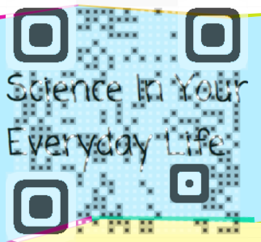
Nearpod 101
By Alicia Yost and Sonya Miles

Step-by-step Instructions: How to Create a Nearpod Presentation

- Log in to www.nearpod.com

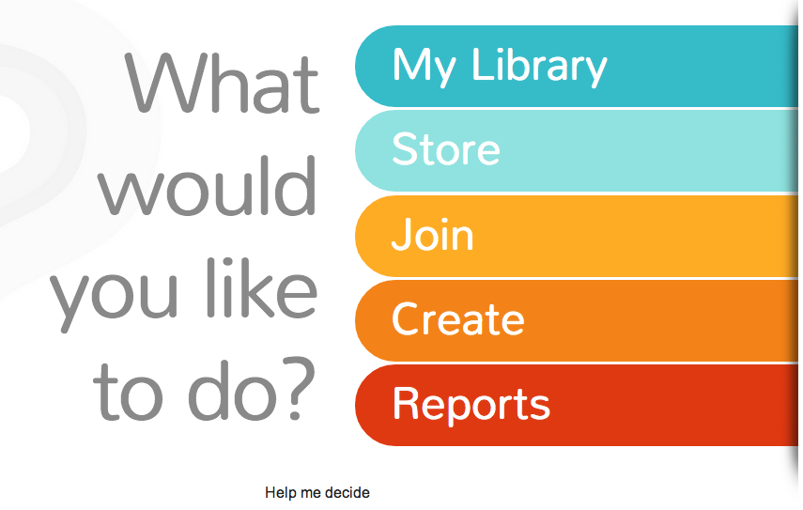
- Click on “create”
  - This will take you to a page with your presentations.

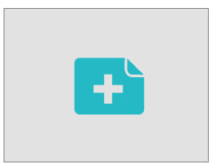
- Click the “+” sign to begin a new presentation.

- Simply drop in your file or start from scratch.
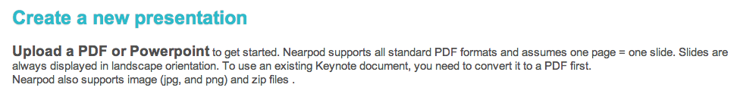
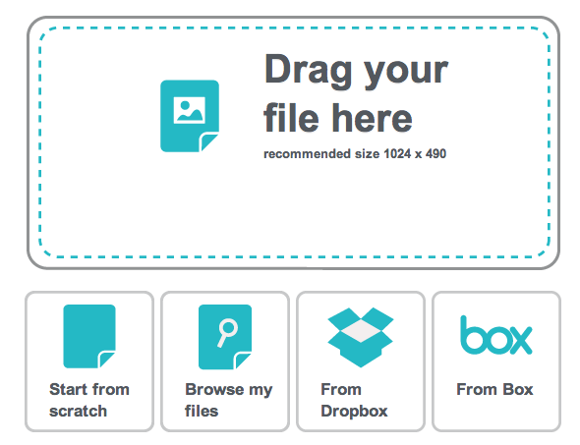

- Again, click the “+” to add a new slide to your presentation.
  - To rearrange the order, drag and drop the slides.
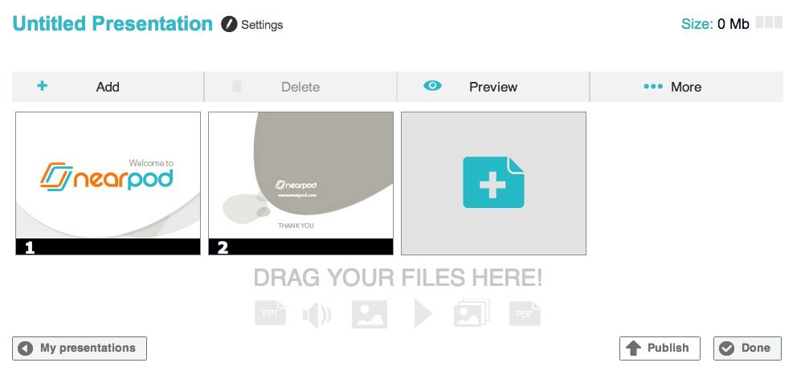

- Add content or an activity (or a web content, if you upgrade).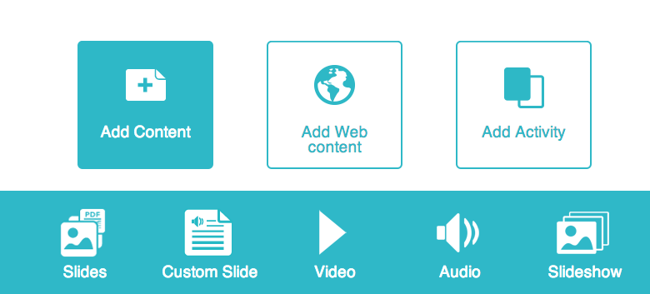 or 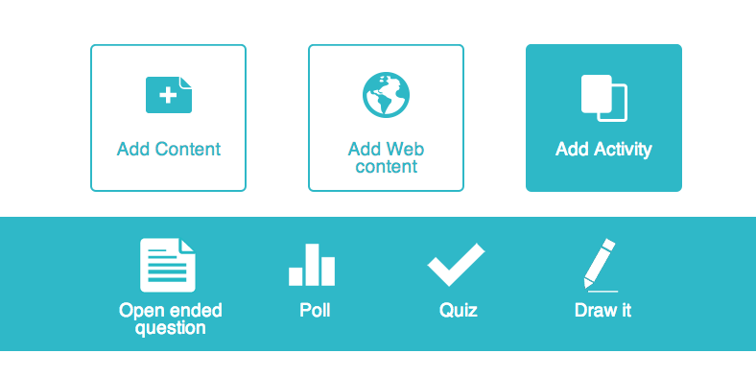

- Each option above will have a slightly different look. Add the information you want for that particular slide. *Notice that on some options you are able to add an image.

- Once you have added all of the slides you desire, click “done” if you want to go back and edit later or “publish” if you are finished and wish to use the presentation with a class. You will be taken back to your “presentations” page. *You must “Publish” before you can use the presentation in your classes.

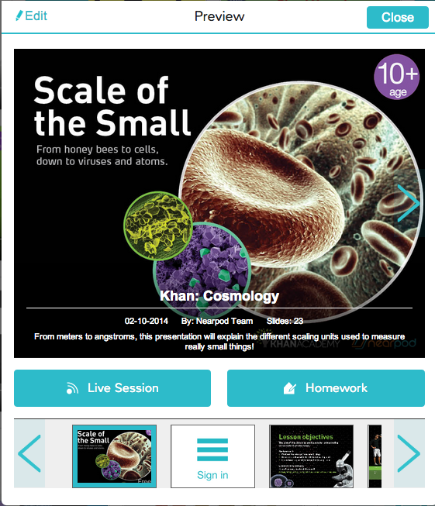
- To use a Nearpod presentation (NPP) with a class, simply click on the presentation.
  - You can edit.
  - Start a live session in class
  - Or send as homework – I usually just copy and
paste the link to add it to my class Weebly website.

TIPS:

1. When adding a quiz, make sure to number the questions. It will simplify your communication later.

2. Look for the settings icon to add even more customization to your interactive features. Example: You can add a reference image for question or have short answer responses instead of multiple-choice questions.
3. The “Draw It” feature has great potential across all curricula. Examples include: annotating over a passage, drawing/labeling a map, solving a math problem, balancing chemical equations, and more.

Sources:
All images in the instructions were taken from www.nearpod.com

