Earth’s Structure: Quizlet and Review

Go to: www.quizlet.com/30971085

1. Start by going over the flashcards for 5 minutes. Initial when finished: _______________

2. Click on “learn”. Work on this until all 11 words are “learned”. Initial: ________________

3. Click on “speller”. Play until you get 7/7. Initial when finished: _____________

4. Take the test. Score: ___________________ Retake (if necessary): ________________

5. Play Match. Scores: _____________, ______________, ______________, ___________, _____________
*Circle your best score.

6. Play Gravity. Scores: _____________, _____________, _______________

Review Questions:

1. Imagine that you are taking a journey through the center of Earth. You start in space over the crust. You are in a space ship that can withstand high temperature and pressure. You stop several times on your ship to collect data. Describe two characteristics of each layer as you go. Atmosphere, crust, water, mantle, outer core and inner core.

2. You are building a model of Earth based on the density of layers. What materials would you use for each layer? Include water and atmosphere.

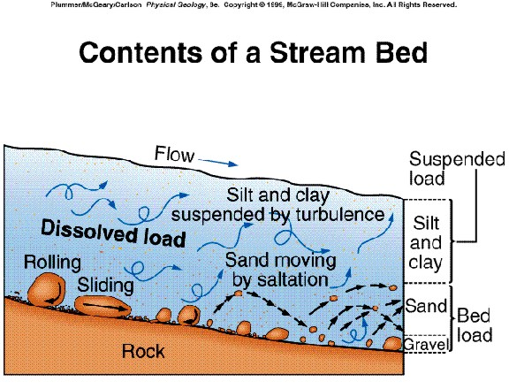

3. If a rock has a volume of 7 cm³ and mass of 35 g, what is its density? SHOW YOUR WORK!

4. Describe which types of particles are likely to go the furthest in a stream? Why?

5. Describe which types of particles are likely to be left upstream, especially if the river is NOT a large one? Why?

6. What two factors determine how materials are sorted here on Earth’s surface?

7. Come up with an object that can be used as a model of Earth’s layers. Describe how it is accurate and inaccurate.

8. Compare the density of the layers of the Earth to their relative positions.

