Discovering Cells Guided Notes

A. Discovering Cells (page 1)

- Two things that a rhinoceros, mushrooms and an oak tree have in common: _________________________________________________________________________________________________________________
- Cells are the basic units of ____________________________ and ___________________________ of all living things.
- Like bricks of a house, cells are the __________________________ ____________________________ of life.
- Can you see the individual cells on your arm? YES or NO Explain why not.

B. First Sighting of Cells (pages 1 and 2)

- When was the first microscope invented? _________________________________________________________________
- What is a microscope? _______________________________________________________________________________________
_____________________________________________________________________________________________________________________
- A light microscope that has more than ___________________________ lens is called a ________________________ microscope.

C. Robert Hooke (page 2)
8. The English scientist who was one of the first people to observe cells: ______________________________
9. What did Hooke look at when he first saw cells? ______________________________________________________
10. What most amazed Hooke was how many cells the cork contained. He calculated that in a cubic inch there were about ________________________________________________________ cells.

D. Anton van Leeuwenhoek (page 3)
11. Leeuwenhoek, a Dutch businessman and amateur scientist, looked at ________________________________.
12. To his surprise he saw one-celled organisms that he called ____________________________________________, meaning “little animals”.
13. When he looked at _______________________________________ scrapings, he became the first person to see tiny single-celled organisms that are now called ____________________________________________________.

E. The Cell Theory (page 4)
14. Over the years, scientists have continued to use and improve the ___________________________________.
15. In 1838, Matthais Schleiden concluded that all _________________________________ are made up of cells.
16. In 1839, Theodor Schwann concluded that all _____________________________ are also made up of cells. Thus, all ____________________________ ____________________________ are made up of cells.
17. The cell theory states:
- ____________________________________________________________________________________________________________
- ____________________________________________________________________________________________________________
- ____________________________________________________________________________________________________________

Analysis Questions:
1. How has the technology of science helped to further the progress of the study of cells? Use examples from the readings.

2.
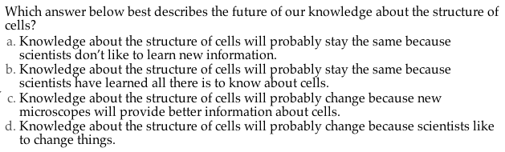
3. Read: SEM stands for scanning electron microscope. The SEM is a microscope that uses electrons instead of light to form an image. Since their development in the early 1950's, scanning electron microscopes have developed new areas of study in the medical and physical science communities. The SEM has allowed researchers to examine a much bigger variety of specimens.
The scanning electron microscope has many advantages over traditional microscopes. The SEM has a large depth of field, which allows more of a specimen to be in focus at one time. The SEM also has much higher resolution, so closely spaced specimens can be magnified at much higher levels. Because the SEM uses electromagnets rather than lenses, the researcher has much more control in the degree of magnification. All of these advantages, as well as the actual strikingly clear images, make the scanning electron microscope one of the most useful instruments in research today.

