Density Review

Vocabulary—Go to http://quizlet.com/_fkmuc to define the following terms AND use the word in a sentence (refer to a lab or demonstration we used in class):

- Mass— The amount of ___________________________ (atoms) in an object.
  - _____________________________________________________________________________________________________________________
- Volume— The amount of ____________________________ something takes up.
  - _____________________________________________________________________________________________________________________
- Density— The amount of ______________________ per given ____________________.
  - _____________________________________________________________________________________________________________________
- Meniscus— The _______________________________ in the upper surface of a liquid close to the surface of the container.
  - _____________________________________________________________________________________________________________________
- Triple beam balance— A laboratory instrument used to measure the __________________________________ of an object.
  - _____________________________________________________________________________________________________________________
- Graduated cylinder— A laboratory instrument used to measure the _____________________________________ of a liquid.
  - ______________________________________________________________________________________________________________________
- Water Displacement— When an object is immersed in a _____________________________ pushing it out of the way and taking its place. The volume of the ______________________________ displaced can then be measured, and from this the volume of the immersed object can be determined (the volume of the immersed object will be ____________________ equal to the volume of the displaced fluid).
  - ______________________________________________________________________________________________________________________
- Ruler— Used to measure the __________________________ of objects.
  - ______________________________________________________________________________________________________________________
- Beaker— A laboratory instrument used to measure ________________________________, but not acutely as a graduated cylinder.
  - _____________________________________________________________________________________________________________________
Play the Games:
High score for Scatter: ________________ High score for Space Race: __________________

1. What tool did we use in class to measure the mass of an object? What are the units?

2. How do you find the volume of a square or rectangular object? (What is the formula?)

3. How do you find the volume of an irregularly shaped object?

4. What is the volume of an object that has a height of 4.3 cm, a width of 2.6 cm and a length of 1.3 cm? (SHOW YOUR WORK)

5. An object is dropped into a graduated cylinder containing 25 ml of water. The new volume is 37 ml. What is the volume of the object? (SHOW YOUR WORK and draw the before and after pictures of the graduated cylinder. Don’t forget the meniscus!)

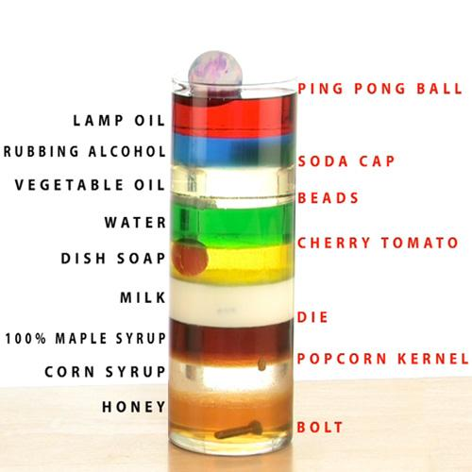
Use the image to the right to answer questions 6-10.
6. Which object is the least dense?

7. Which liquid is the most dense?

8. Which is more dense, the water or dish soap?

9. What do you know about the relative density of the popcorn kernel? (hint: compare its density to the objects and liquids around it.)

10.The beads are at the bottom of the vegetable oil. What does that tell you about the density of the beads compared to the vegetable oil?

11. Why do life jackets help people float? (use the word density in your answer)

12. What is the correct formula for density? (hint: remember the heart)

13. If a golf ball has a mass of 46 grams and a volume of 33 cm³, what is the density of the ball?

14. If density has a density of 1.36 g/cm³ and the mass is 52 grams, what if the volume of honey?

15. Draw three squares. In each square, use dots to represent particles. Draw the first with low density, the second with medium density and the last one with high density.

16. The two cans of soda, Diet Coke and Coke, were the same size, but one was heavier than the other. What does that tell you about the number of particles in the given space? (Write your answer in complete sentences.)

17. What did you learn about the density of gases from the experiments we did in class?

