 | OBJECTIVE: | NAME:
 |  | PERIOD:
 |  | DATE:
ESSENTIAL QUESTION: Why are the Earth’s layers positioned the way that they are?
QUESTIONS: | What have you already learned about the layers of the Earth?
 | Density and Earth’s Structure (Draw the picture)
 | Model of the Earth: Pick something that could represent the Earth and its layers. Draw and label it below.
 | What patterns did you see in the pictures? Why are the layers positioned the way that they are?
Fill in the blanks:
- _______________: Materials are sorted according to their ____________
  - Most dense materials settle to the _________________________
  - ________________ dense materials go to the top.
- How would gold, aluminum and lead be sorted according to their densities?

Particle size: materials are also sorted according to ______________ _________

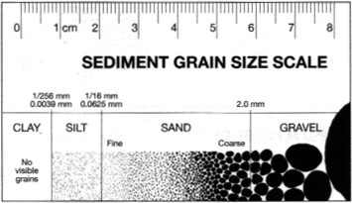

How would the sediments sort as the energy of the river decreases? Draw it!

Explain your answer above.

- Rivers: sand easily travels ____________________ (due to _______ from water), whereas ____________ are most likely to remain _____________.
  - Sediments in streams wear down rocks over time.
- Road cuts: layered materials with different _________________ and particle sizes of materials.
- Beaches: sand is likely to wash onto shore due to __________________ (again, ______________ is the cause)
SUMMARY:

