Classifying All Organisms

Objective: I can arrange organisms according to kingdom (plant, fungi, animal, protist, Archaebacteria/Eubacteria)

Procedure:
1. Fill in the chart below.
2. Create a classification tree AND a dichotomous key from the information in the table.

Domain/Kingdom | Single or Multi-cellular | Cell Wall | Producer or Consumer | Nucleus
1. Bacteria (Archaebacteria/
Eubacteria)
2. Protista
3. Fungi
4. Plantae
5. Animalia

Classification Tree:

Dichotomous Key:
1a. ___________________________________________ go to ______
1b. ___________________________________________ go to ______
2a. ___________________________________________ ……… _________________
2b. ___________________________________________ ……… _________________
3a. ___________________________________________ ……… _________________
3b. ___________________________________________ ……… _________________
4a. ___________________________________________ ……… _________________
4b. ___________________________________________ ……… _________________
Analysis Questions:
1. Which domain has cells with a nucleus? ________________

2. Which kingdom is it?
A. Is multicellular, cannot produce it’s own food, has NO cell wall. ____________
B. Is single-celled, some produce their own food, nucleus. __________________
C. Is single-celled, has no nucleus. ____________________________________
D. Is multicellular, can produce it’s own food, cell wall. _____________________
E. Is multicellular, cannot produce it’s own food, has a cell wall. ______________
3. Which bacteria domain is the oldest domain and is considered the origin of life?

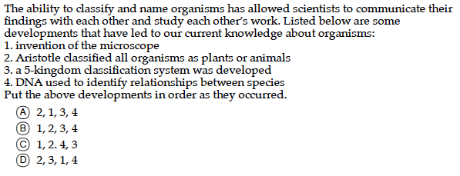
4.

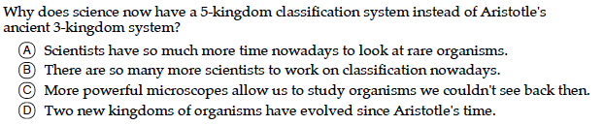
5.

