Levels of Organization Review (C6-C9)

- What are the 5 levels of cell organization from simplest to most complex?

- Give an example of each that you might find in a cat?

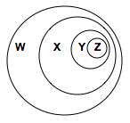

- Use the diagram to answer the next two questions. Overlapping circles can be use to show relationships. In this diagram, levels of organization within living things are shown.
  - If each circle is made from the smaller circles inside it, what would circle “X” stand for?

  - What would circle “Z” stand for?

- List three examples for each of the levels of organization.

- Which organ system collects and excretes cell wastes? _______________________________________

- Which organ system breaks down food? _______________________________________________________

- Which organ system allows for the exchange of oxygen and carbon dioxide? Explain

- If someone was having trouble with pains in the stomach, they would go to a doctor that studies which body system? Explain.

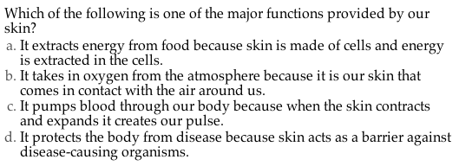

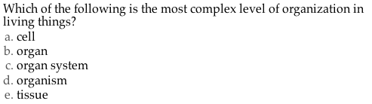

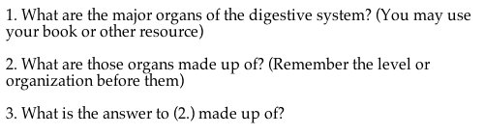
- C

