Body Systems

Review: Place the following words into the correct boxes below.
- Brain, nerve cell, the lining of the stomach, a bird, a tendon, a red blood cell, skin, an elephant, the entire digestive tract, and your skeleton.
Cell | Tissue | Organ | Organ system | Organism

- What is the difference between a tissue and an organ?

- What is the difference between an organ and an organ system?

- What is the function of the circulatory system?

- What are the major organs of the circulatory system?

  - What are those organs made of (levels of organization)?

  - What are the answers to a. made of (levels of organization)?

- How do the chambers of the heart and the valves between them affect the circulatory system?

- What is the function of the respiratory system?

- How do the alveoli (tiny sacs that fill with air during breathing) help the lungs do their job?

- What is the digestive system?

- List some of the organs that make up the digestive system.

- Why does the stomach need to be made of muscle tissue?

- What is the nervous system?

- What are the two main organs of the nervous system?

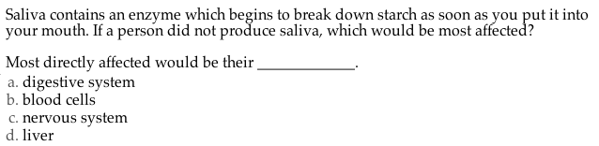

14.
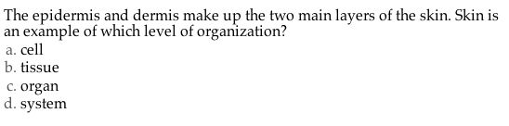
15.
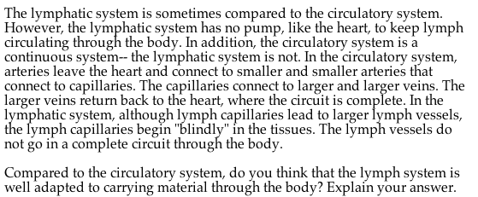

16.
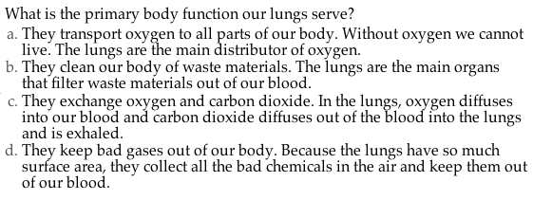
17.

18.
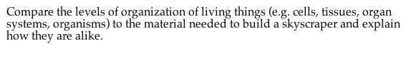

20.
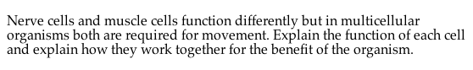

21.
