Atoms and Molecules Review
Study assignments # _______________ to prepare for the M1-M5 Test on Friday!!!!!

M1 | I can compare the size of atoms to other objects. | ____ Yes | ____ No

1. What is the smallest unit of matter that has it’s own recognizable identity? ________________

2. Why is it difficult to draw an atom? Explain

3. List 4 items larger than an atom and 4 items smaller than an atom.
Smaller | Larger

4. Draw an atom. What are some limitations of the atomic model? (In other words, what are two things that are wrong with your drawing when compared with a real atom?)

M2 | I can explain the differences between atoms and molecules (e.g. atoms combine to make molecules). | ____ Yes | ____ No

5. Multiple atoms being held together by a bond is called a(n)____________________________.

6. Which one of these is an atom? Which is a molecule? How do you know?

7. What is a lump of pure gold (Au) made out of? (Atoms or molecules)

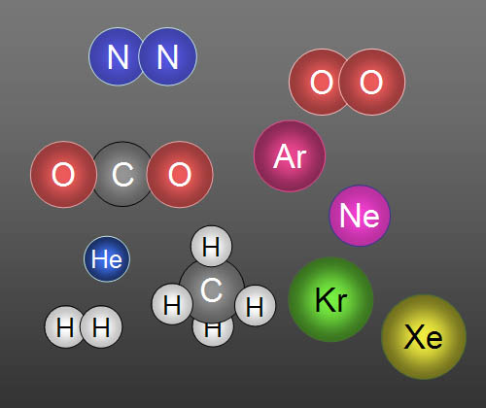
8. What is the compound NaCl made out of? (Atoms or molecules)

9. In the image to the right, put a SQUARE around the atoms and an OVAL around the molecules.

M3 | I can diagram the arrangement of particles in the physical states of matter. (i.e. solids, liquids, and gases). | ____ Yes | ____ No

10. Fill in the blanks with the word definite (it stays the same) or indefinite (it changes).
A. Solids have a(n)_____________________shape and a(n)___________________volume.
B. Liquids have a(n)_____________________shape and a(n)__________________volume.
C. Gasess have a(n)_____________________shape and a(n)___________________volume.

9. Draw AND describe the particles in the following states of matter.
Liquid

Solid

Gas

M4 | I can explain that atomic models are not perfect, but can help us learn about atoms and their characteristics. | ______ Yes | ______ No

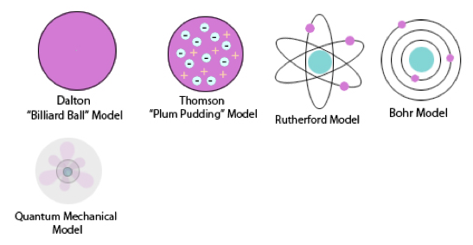

10. List one way each of the atomic models above is accurate and one way it is inaccurate.
Accurate: | Accurate: | Accurate: | Accurate: | Accurate:
Inaccurate: | Inaccurate: | Inaccurate: | Inaccurate: | Inaccurate:
11. Why do we use models to represent the atom?

12. Can we see atoms? Explain.

M5 | I can provide examples of how the atomic model has changed through the years because we have learned more about the atom. | ______ Yes | ______ No

13. In what year did Democritus first begin his theory about atoms? __________________________

14. Since then, how long has it taken scientists to figure out the structure of the atom? Explain.

15. Name 3 other scientists that helped in the discovery of the atom and its subatomic particles and describe what they discovered.

Name: | What they discovered.
A.
B.
C.

16. What does “atomos” mean? ___________________________

17. Draw and label the parts of a Neon atom. (Make sure you have all of the subatomic particles)
P =
e =

N =

18. Draw a picture comparing the size of the nucleus to the whole atom. (Think of the example we used when we went outside.)

VOCABULARY REVIEW:

Go to the website--- http://tinyurl.com/qco33jy
(Also on the class weebly http://yostscience.weebly.com/vocabulary-review.html )

Fill in the chart. Put the definitions in your own words.

Word: | Definition:
1 | The smallest particle of an element that retains its chemical properties (___________________).
2
Molecule

3 | A substance consisting of atoms which all have the same number of _____________ - i.e. the same ___________ ______________
4  A___________  T___________ | 1. All substances are made of ____________. Atoms are the smallest particles of matter. They cannot be divided into smaller particles. They also cannot be created or destroyed.  2. All atoms of the same element are alike and have the same mass. Atoms of different elements are different and have different masses.  3. Atoms join together to form compounds/molecules. A given compound always consists of the same kinds of atoms in the same ratio.
5  P______________ | A minute (very small) portion of matter
6 | Anything that takes up s_________ and has v__________.
7  S__________ | Definite _______________ and definite ______________. Particles _______________ in place.
8 | Definite volume, variable (changing) shape. Particles can _____________________ past each other.
9  Gas | No definite_____________________, no definite ____________. Particle are spread out.
10 | a three-dimensional _________________ of a person or thing or of a proposed structure, typically on a __________________ scale than the original.

**Bonus: On a computer at home tonight (or at the school or library), play “Scatter” at the same website above. Write down your best time here: _______________

