Atom Models Comparison

A model is a two or three-dimensional ___REPRESENTATION_____ of a person or thing or of a proposed structure, typically on a ______SMALLER_______ scale than the original. If the nucleus of an atom were the size of a ______MARBLE______ , and the electrons were the size of __GRAIN__________ _OF_ ____SAND_____ , then the electrons would be __25 METERS____ away from the nucleus.
Draw a picture of the above analogy. Include labels.

Helium Atom
25 meters

Grain of sand Grain of sand
(Electron) Marble (Electron)
(Nucleus)

Model Creator/ Picture | Accurate | Inaccurate
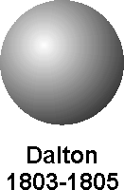 | It shows that the smallest particle of matter is the atom. | Does not show any subatomic particles.
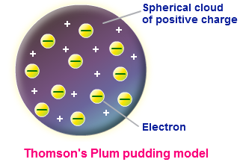 | Shows the charges of subatomic particles. | Does not show a nucleus.
Model Creator/Picture | Accurate | Inaccurate
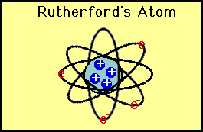 | Shows the atom has a nucleus.  Shows the charges of subatomic particles.  Shows that most of the mass of an atom is in the nucleus.  Shows that electrons orbit the nucleus. | Cannot show the speed of the electrons.  Cannot show the correct amount of empty space in the atom.
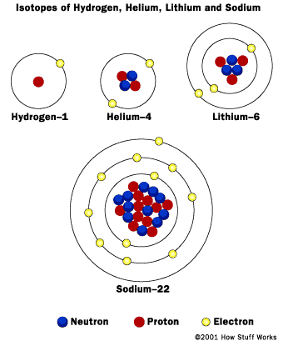 | Shows the atom has a nucleus.  Shows the charges of subatomic particles.  Shows that most of the mass of an atom is in the nucleus.  Shows that electrons orbit the nucleus. | Cannot show the speed of the electrons.  Cannot show the correct amount of empty space in the atom.
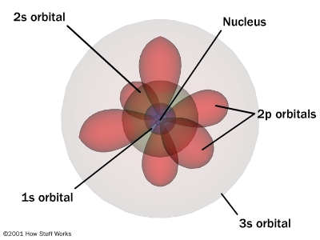 | Shows the atom has a nucleus.  Shows the charges of subatomic particles.  Shows that most of the mass of an atom is in the nucleus.  Shows that electrons orbit the nucleus. | Cannot show the speed of the electrons.  Cannot show the correct amount of empty space in the atom.

