Solids, Liquids, Gases
Objective: I can diagram the arrangement of particles in solids, liquids, and gases
Station 1
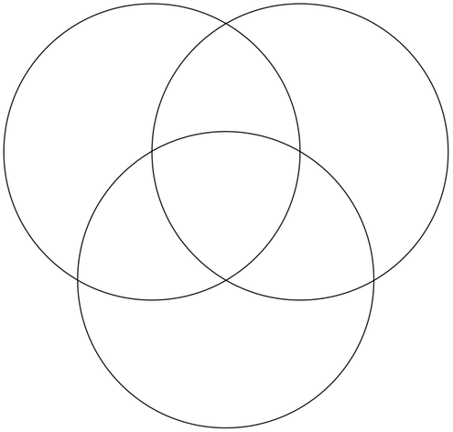
Instructions: Use the book pages 174-179 to fill in the triple Venn diagram for solids, liquids and gases. Include the definition, a drawing, a description of its volume (space), a description of its shape, and a description of the motion of particles it each phase.
Solids
Liquids
Station 2
Gases
Instructions: Go to http://teacher.scholastic.com/activities/studyjams/matter_states/ . Watch the video, answer the questions below, and take the quiz.

1. Draw arrows on the pictures to represent the movement of the particles in one second for each phase.
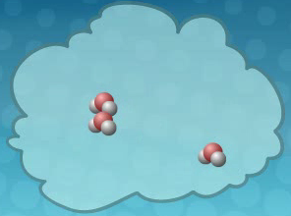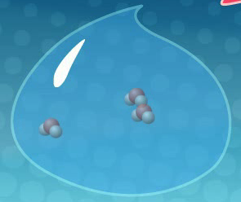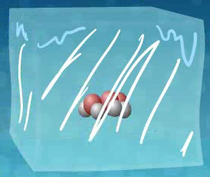

2. Quiz score: ___________
Station 3
Instruction: Draw the Erlenmeyer flask with the balloon at 2 min, 4 min, and 6 min. Use x’s to represent the particles. Use arrows to show speed and motion of the particles in each phase.

0 minutes | 2 minutes | 4 minutes | 6 minutes

Station 4
Instructions: Draw X s to represent the particles in each of the following phases. Write the definition of each phase under the box.

Solid Liquid

Gas

Station 5
Instructions: Complete one of the approved writing activities (see instruction cards).

Writing Instructions:

Option 1—Superhero
Introduction: Congratulations! You have just been hired as an Action Hero Designer for the Science Toy Company! Your first assignment in your new job is to create 1 new action hero for one of the phases of matter. Your Phase Action Hero you design must have powers that reflect the characteristics of that phase. For example, a Liquid Phase Action Hero could have the ability to “shape shift” because liquids take on the shape of whatever container they are in. Good luck and enjoy your new job!

Requirements for your Phase Action Heroes Design:
- A description of your Phase Action Hero. You must include 5 characteristics for each Phase Action Hero. You can describe their powers, their weaknesses, their personalities, and their likes and dislikes. Remember, their descriptions must represent their phase of matter.
- BONUS: Include a picture of your Superhero.

Option 2 and 3—Poem or Song
Write a poem or song about the differences between solids, liquids and gases. Include key words such as solid, liquid, gas, condensation, evaporation, freezing point, boiling point, slow down, speed up, particles and others.

Option 4—Comic
Draw a 4 panel comic strip about how substances change from one phase to another. Include key words such as solid, liquid, gas, condensation, evaporation, freezing point, boiling point, slow down, speed up, particles and others.

