 | TOPIC/OBJECTIVE: | NAME:
 |  | CLASS/PERIOD:
 |  | DATE:
ESSENTIAL QUESTION:
QUESTIONS/CUES/KEY WORDS/ MAIN IDEAS: | Metric Mania
How much does it hold?

___________________________ or ___________________________

Imperial Units: ______________________________________________________

Metric Units: (L)
How heavy is it?

____________________________ or ________________________________

Imperial Units: ______________________________________________________

Metric Unit: (g)
How heavy is it?

______________________________ or ________________________

Imperial Units: ______________________________________________________

Metric Unit: (m)
Summary—Base Units

_____________________________ = Liter (L)

_____________________________ = Gram (g)

_____________________________ = Meter (m)

*There are others, but these are the three examples we’ll use for conversions
 | List some example of prefixes we use every day:
The prefixes we’ll focus on with the three example base units:

_______________, ______________, ______________, base unit (m, L, g),

_______________, ______________, ______________

Mnemonic Device:

K______________ H________________ D___________________ Unexpectedly

D__________________ C_______________________ M___________________

K H D Unit (m, L, g) D C M
Abbreviations:

Kilo ______

Hecto _______

Deka ______

Meter _________ gram _______ Liter ________ (Base Units)

Deci ______

Centi ________

Milli _______

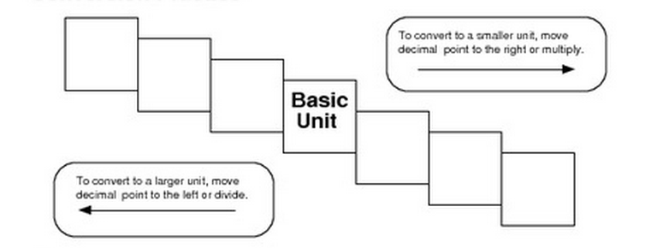
Example 1: Convert 25 hectograms (hg) to centigrams (cg). Show your work

Example 2: Convert 1113 milligrams (mg) to kilograms (kg) Show your work!

SUMMARY:

