Tracks of a Killer- CASE FILE #1
Objectives:
- I can determine if there is a relationship between the length of a person’s stride and his or her height
- I can determine if there is a relationship between the size of a person’s shoe and his or her height.
- I can gather data to test for correlations between height, shoe size, and stride length
- I can use linear regression of collected data to predict height based on stride length
Materials:

- Logger Pro
- Groups of no more than 6
- Meter sticks
- Chalk or tape

Part 1: Collecting Data
- Use the meter sticks to measure each person’s height without shoes to the nearest cm, and record it in your evidence record next to the person’s name.
- Use the meter sticks to measure each person’s right shoe from the tip of the toe to the end of the heel using cm. Record measurements into the evidence record.
- Mark a starting line with tape or chalk. Each person will take turns standing with heels at the edge of the starting line. Take 10 normal-sized walking steps in a straight line. Put your heels together and stop after the tenth step:

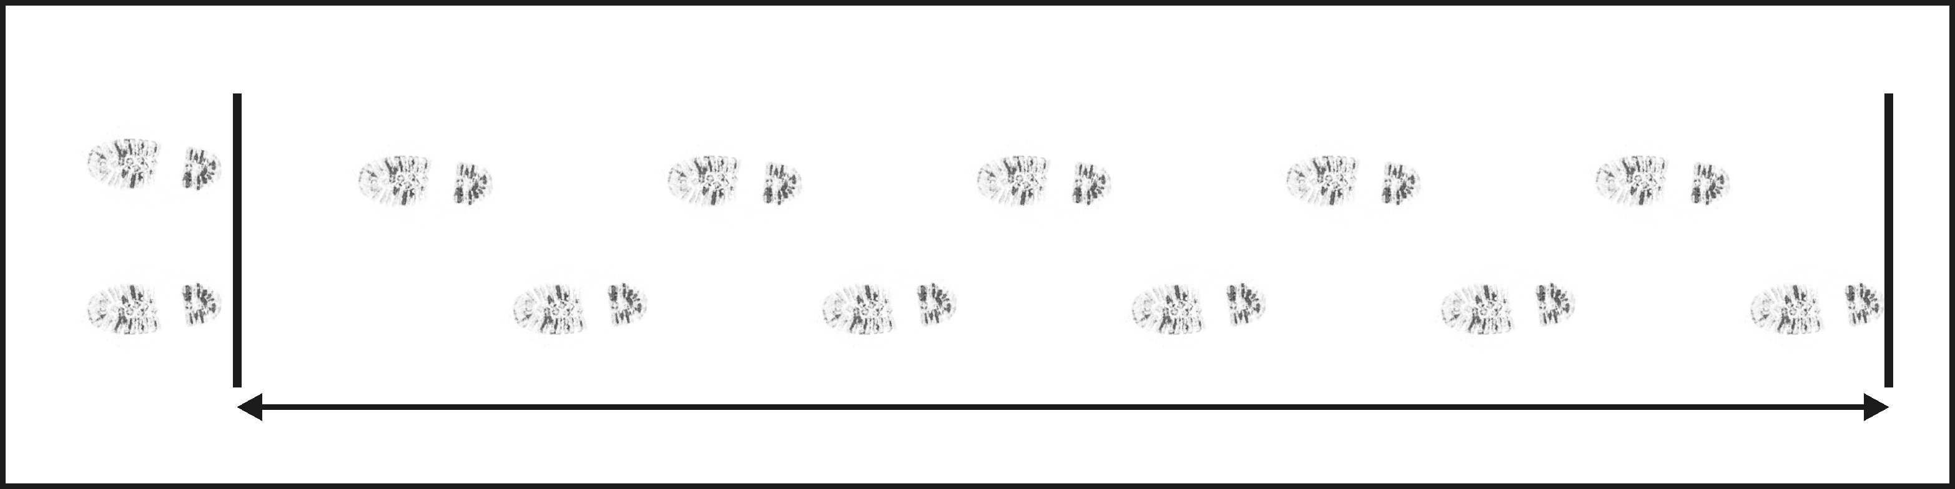
Start line

- Use the meter stick to measure the distance between the person’s heels and the starting point in cm. To determine the average stride length, divide this distance by ten and record it in the evidence record.

Part 2: Entering Data in Logger Pro
- Click on File: New (Discard any data left over from previous users)
- Click on Table: New Manual Column. Don’t change any settings, just click OK in the bottom right corner.
- Your Table will now have 3 columns: X, Y, and Manual Column. You will rename these now:

- Click on the X column and rename as Height and change units to cm
- Click on the Y column and rename as Shoe Length and change units to cm
- Click on the manual column and rename as Stride Length and change units to cm

- Enter the data you collected for height, shoe length, and stride length in to each column by clicking the cells under the columns and typing in the data
Part 3: Analyze the Data
Now, we will determine the best fit line for your data using a specific equation called linear regression. This is college level mathematics, so we will be using Logger Pro to set up the equation for us. This linear regression will help us figure out the relationship between height and stride length.
- Click on the graph button to take you to the graph of your data points.
- There are 2 things shown on your graph: a blue line representing stride length v. height and a red line representing shoe length v. height
- Click on Analyze: Curve fit: Stride length (blue)
- Under fit equation, select Linear. The Correlation tells you how well the line fits the data: The closer the number is to 1, the better the line fits the data. Write down the correlation value on your evidence record.
- Click on OK in the bottom right corner, and this should take you back to the graphs.
- Click on Analyze: Curve fit: Shoe length (red)
- Under fit equation, select Linear. Look at the Correlation and write that value down in your Evidence Record.
- Now you may begin answering the questions on the Case Analysis part of your worksheet.

