Observations & Inferences

Observation—Any____________________ collected with the ______________________.
  - Quantitative – _________________________ or __________________
    - _______________________________ or _________________________________
    - _______________________________ or _________________________________
  - Qualitative – ___________________________ , ___________ measureable.
    - ________________________________ or ________________________________ or _________________________
- The skill of __________________________________________ scientific events
Inference—______________________________ or _______________________________ based on observations.
  - The process of _________________________ ___ _______________________ from given evidence.
Practice 1:

- Observations:
  - I hear people screaming
  - I smell cotton candy, popcorn, and hamburgers
  - I see a lot of people

- Inference = _________________________________________________________________________________________

Practice 2: Mystery Footprints.

Panel 1
3 Observations: | 1 Inference
1.
2.
3.

Panel 2
3 Observations: | 1 Inference
1.
2.
3.

Panel 3
3 Observations: | 1 Inference
1.
2.
3.

Conclusion: Describe HOW and WHY your inference changed with each panel? ______________________________________________________________________________________________________________________________________________________________________________________________________________________________

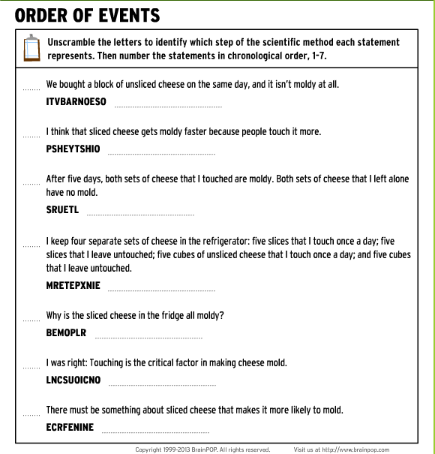
BrainPop: The Scientific Method

