Just How Small is an Atom?

Objective for this “flipped” lesson: I can compare the size of atoms to other objects.

Instructions:
1. Go to the following website: http://ed.ted.com/lessons/just-how-small-is-an-atom
2. Complete the following guided notes with the video. You may have to stop, rewind, or even watch the video again in order to complete the following.
3. There will be a short quiz tomorrow!

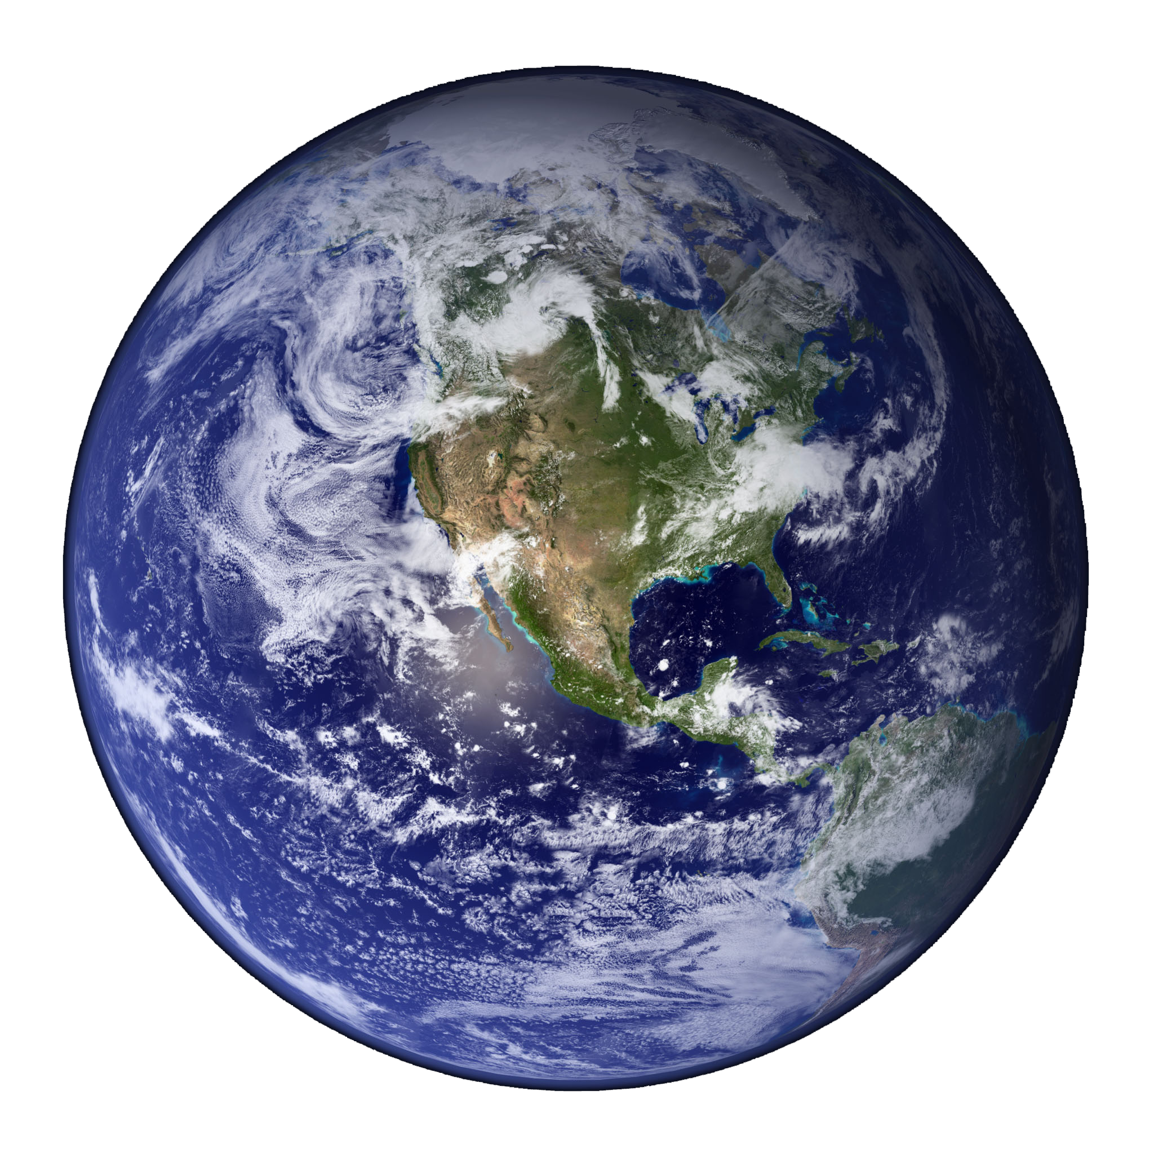
Notes:

Matter is anything that takes up space and has volume.

Everything is made up of little tiny things called _________________________________. Each atom is made up of subatomic (sub means “smaller than”; atomic is referring to an atom = smaller than an atom) parts called _____________________________ , _________________________________ , and ______________________________________.
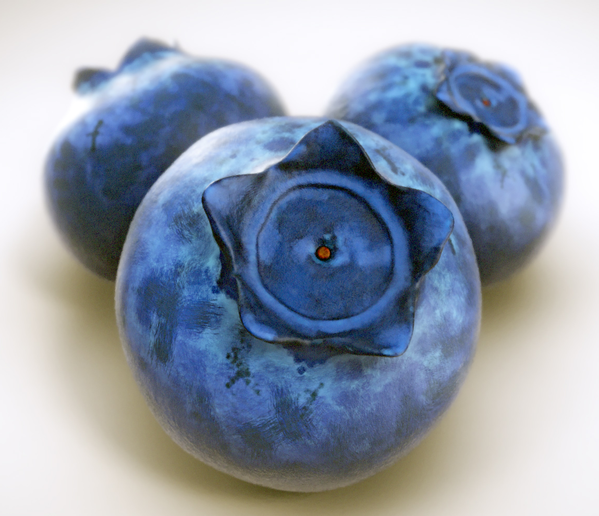
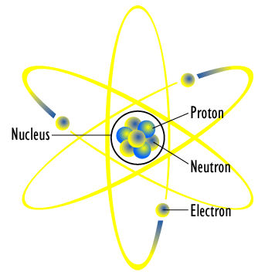
If each of the Nitrogen atoms in a grapefruit were blown up to the size of a blueberry, how big would the grapefruit be? _____________________________________________________________

“So if I filled the Earth with blueberries, I would have the same number of Nitrogen atoms as a grapefruit?” __________________________________________

In the center of the atom you find a ___________________________________, which contains the ____________________________ and the _______________________________.

The picture of the atom to the right is NOT to scale.

If a blueberry (an atom) were the size of a football stadium, then the nucleus would be the size of a __________________________________________ .

What is contained between the nucleus in the center and the electrons on the edge? Surprisingly the answer is _________________________________ ____________________________________ .

