DNA Structure Notes
- DNA is often called the __________________________ of life.
- DNA contains the ________________________ for making ____________________ within the cell.
- DNA is like the ____________________________ _______________________ for a computer.
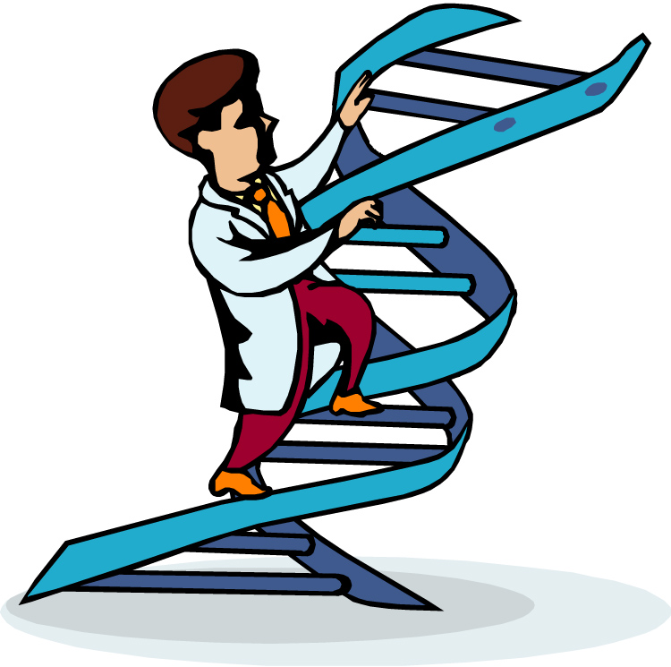
The Shape of the Molecule
- DNA is a very long polymer. (chain of nucleotides)
- Basic shape is like a twisted ladder or ________________________. (See the picture )
- Called a _______________________ _____________________.

The Double Helix Molecule
- The DNA double helix has ___________________ strands twisted together.
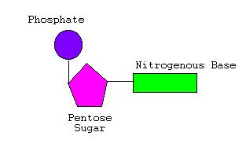
Nucleotides
One deoxyribose together with its ______________________ and base make a nucleotide.

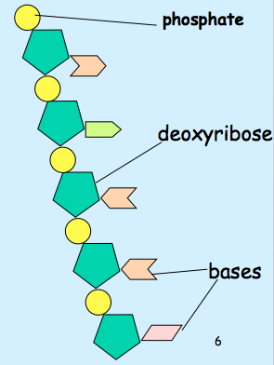
One Strand of DNA
- The backbone of the molecule is alternating phosphates and deoxyribose sugar.
- The teeth are nitrogenous bases.
- One strand of DNA is a polymer of nucleotides.
- One strand of DNA has many _____________________ of nucleotides.

Four nitrogenous bases
- Cytosine C
- Thymine T
- Adenine A
- Guanine G

Two Stranded DNA
- Remember, DNA has _______________ strands that fit together something like a zipper.
- The teeth are the nitrogenous bases but why do they stick together?

Hydrogen Bonds
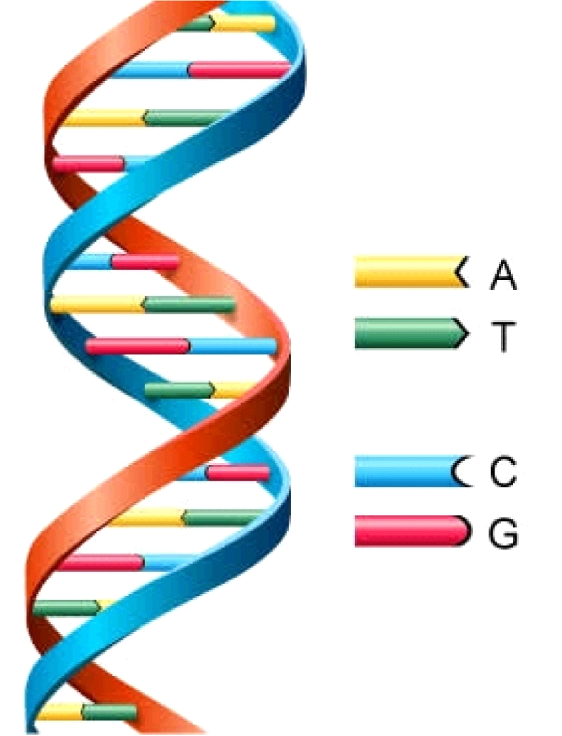
- Hydrogen bonds are weak but there are millions and millions of them in a single molecule of DNA.

Important: (draw the arrows)
- Adenine and Thymine always join together A T
- Cytosine and Guanine always join together C G

DNA by the Numbers
- Each cell has about _______________________ meters of DNA.
- The average human has _______________________________ cells.
- The average human has enough DNA to go from the earth to the sun more than _____________________times.
- DNA has a __________________________ of only 0.000000002 meters.

Analysis Questions:

1. What are the three main parts of a nucleotide?

2. What is the basic shape of DNA?

3. DNA has the instructions for making what in a cell?

4. Why is DNA important?

5. Cytosine always bonds (matches up) with __________________________.

6. Adenine always bonds (matches up) with ___________________________.

7. If you had the following sequence, what would be the matching strand?

ATTGCCGATAGCGATACA

8. How can DNA be used for solving a crime?

Conclusion: Don’t break the bank—Each word costs 10 cents and you have $3 to spend. Write a summary of what you learned about DNA today. (Hint: at 10 cents per word, if you have $3 you can write 30 words. Remember—you can’t spend more or less than $3)

